Republic of the Philippines

CAVITE STATE UNIVERSITY

**Bacoor City Campus**

SHIV, Molino VI, City of Bacoor

**DEPARTMENT OF COMPUTER STUDIES**

**ITEC 106: IT ELECTIVE 2 (Web Systems & Technologies 2) Activity Sheet**

**2nd Semester, A.Y. 2023-2024**

|  |  |
| --- | --- |
| **Name: Yap John Owen** | **Date:** |
| **Course/Yr&Section: BSIT 3-6** | **Score:** |

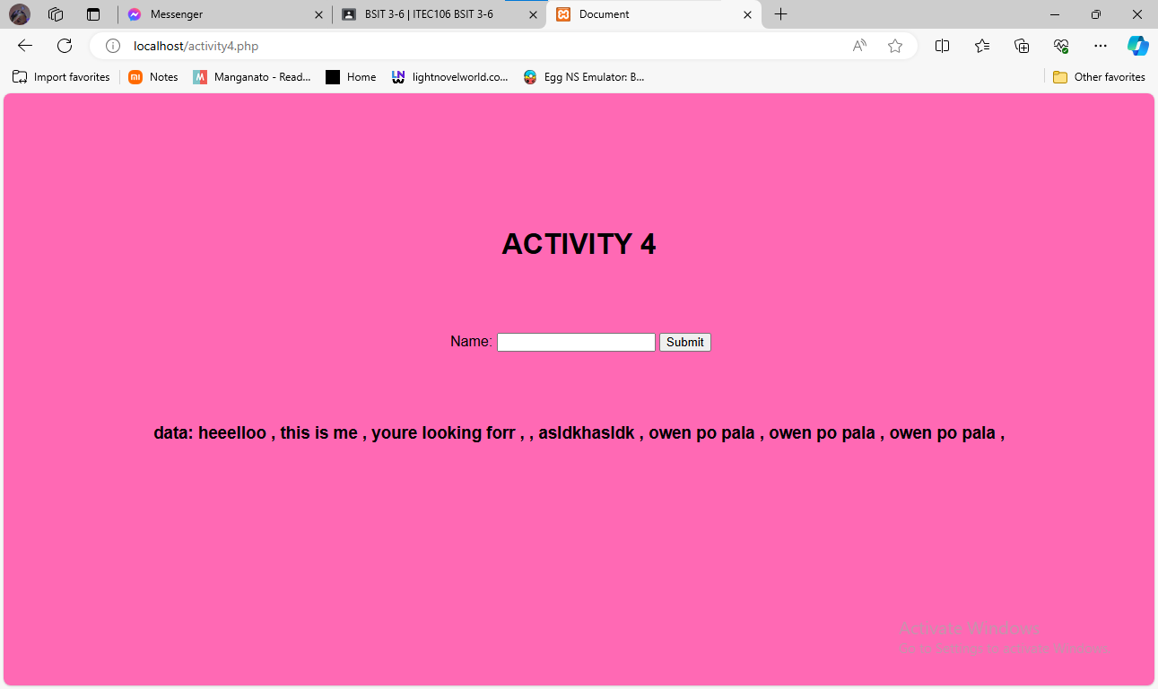

<!DOCTYPE html>

<html lang="en">

<head>

    <meta charset="UTF-8">

    <meta name="viewport" content="width=device-width, initial-scale=1.0">

    <title>Document</title>

</head>

<style>

 body {

 background-color: hotpink;

 font-family: Arial;

 }

.ano {

 padding: 30px 30px;

 margin: auto;

 margin-top: 50px;

 margin-left: 460px;

 }

 h1 {

 margin: auto;

 margin-top: 150px;

 text-align: center;

 text-transform: uppercase;

 }

 h3 {

 margin: auto;

 margin-top: 50px;

 text-align: center;

 text-transform: lowercase;

 }

 </style>

 <body>

 <h1> ACTIVITY 4 </h1>

 <?php

 if (isset($_POST['text'])) {

 $name = $_POST['text'];

 $handle = fopen('data.txt', 'a+');

 fwrite($handle, $name . "\n");

 fclose($handle);

 }

 ?>

 <div class="ano">

 <form method="post">

 Name: <input type="text" name="text" />

 <input type="submit" name="submit" />

 </form>

 </div>

 <div>

 <h3> Data:

 <?php

 $read = file('data.txt');

 foreach ($read as $line) {

 echo $line . ", ";

 }

 ?>

 </h3>

 </div>

 </body>

 </html>